

ISI KANDUNGAN

[RINGKASAN EKSEKUTIF 4](/Users/mac/My Drive/JBS IT EG6 2022 _APLIKASI MENGALINGA/17112022_Laporan Mengalinga Okt 2022.docx" \l "_Toc121234110)

[RINGKASAN STATUS DATA APLIKASI MENGALINGA BAGI OKTOBER 2022 5](#_Toc121234111)

[1. PENDAFTARAN SUKARELAWAN 6](#_Toc121234113)

[DEMOGRAFIK PENDAFTARAN 6](#_Toc121234114)

[SENARAI TRAILBLAZER BAGI SUKARELAWAN 10 TERTINGGI BAGI BULAN OKTOBER 2022 10](#_Toc121234115)

[2. PENDAFTARAN ORGANISASI 13](#_Toc121234124)

[CARTA & PECAHAN PENDAFTARAN ORGANISASI SEHINGGA OKTOBER 2022 13](#_Toc121234125)

[DAPATAN DARI HASIL PENGUMPULAN DATA 15](#_Toc121234126)

[SENARAI HIGHFLYERS BAGI ORGANISASI 10 TERATAS BAGI BULAN OKTOBER 2022 16](#_Toc121234127)

[3. PROGRAM YANG DILAKSANAKAN HINGGA 31 OKTOBER 2022 20](#_Toc121234128)

[DAPATAN DARI HASIL PENGUMPULAN DATA 20](#_Toc121234129)

[KAJIAN PERBANDINGAN 21](/Users/mac/My Drive/JBS IT EG6 2022 _APLIKASI MENGALINGA/17112022_Laporan Mengalinga Okt 2022.docx" \l "_Toc121234130)

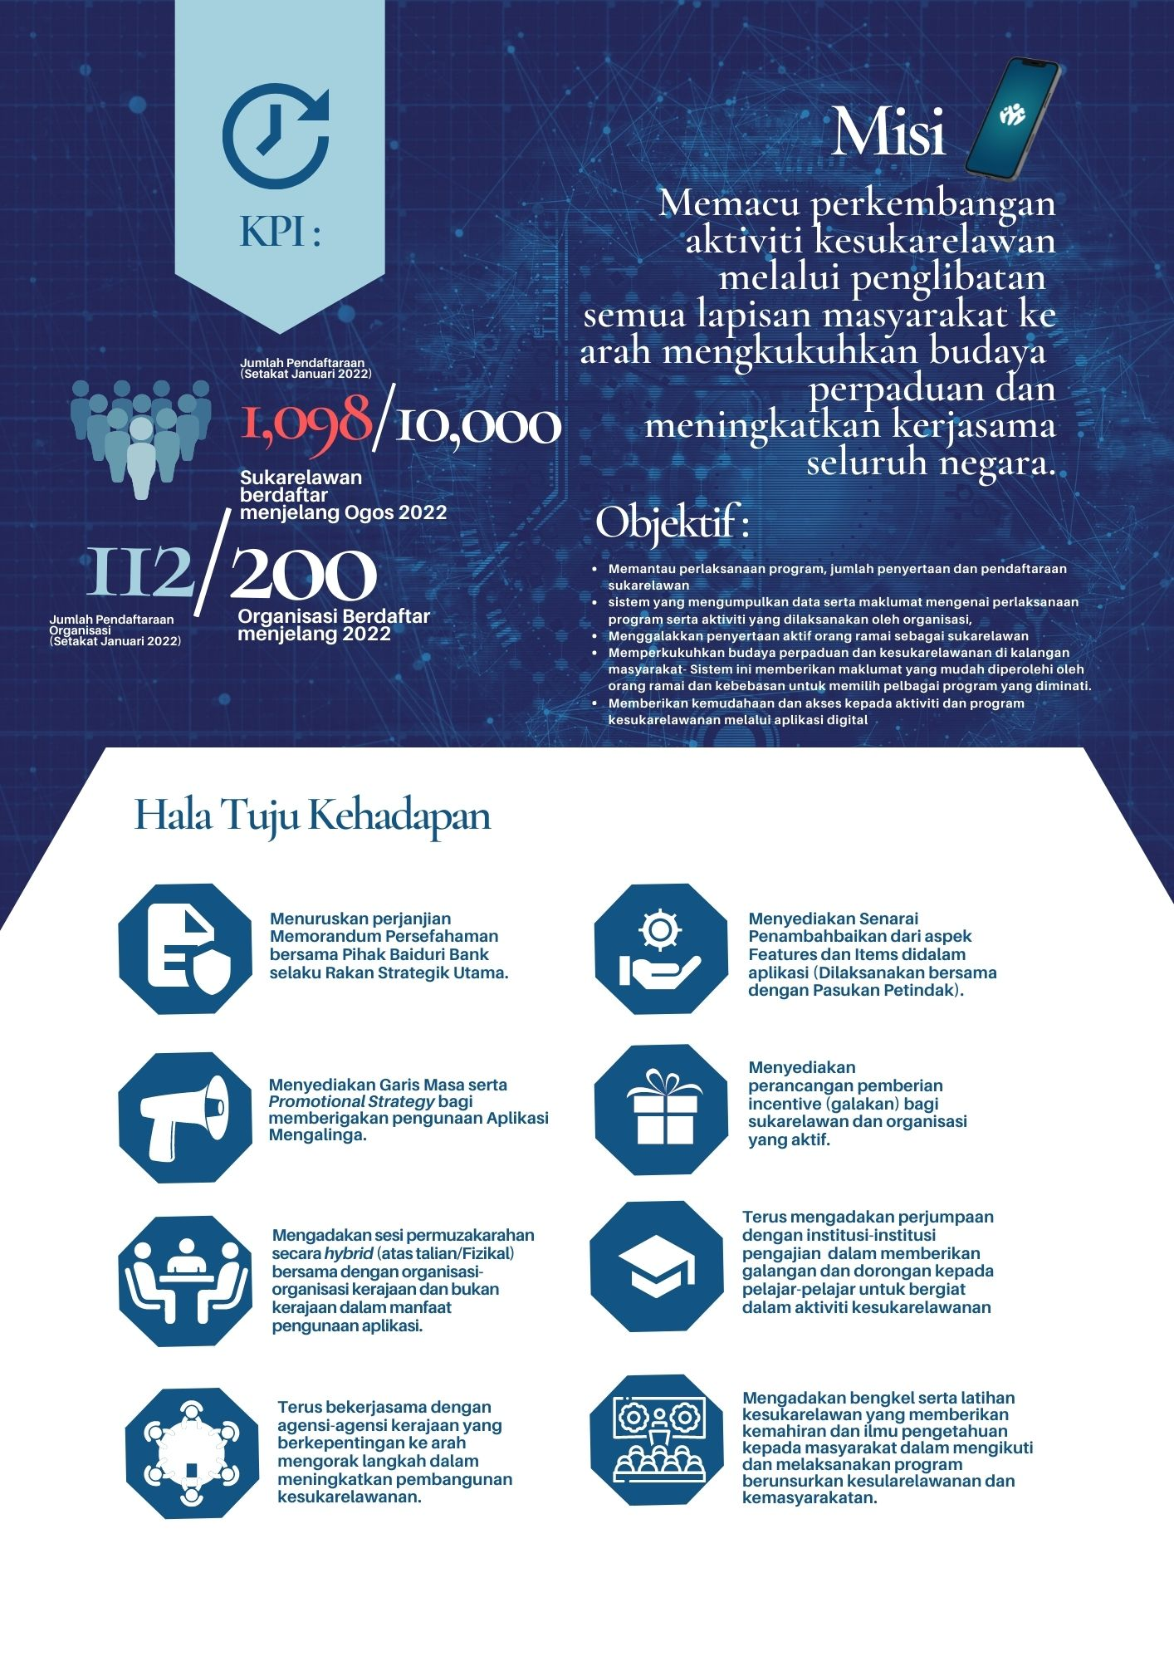

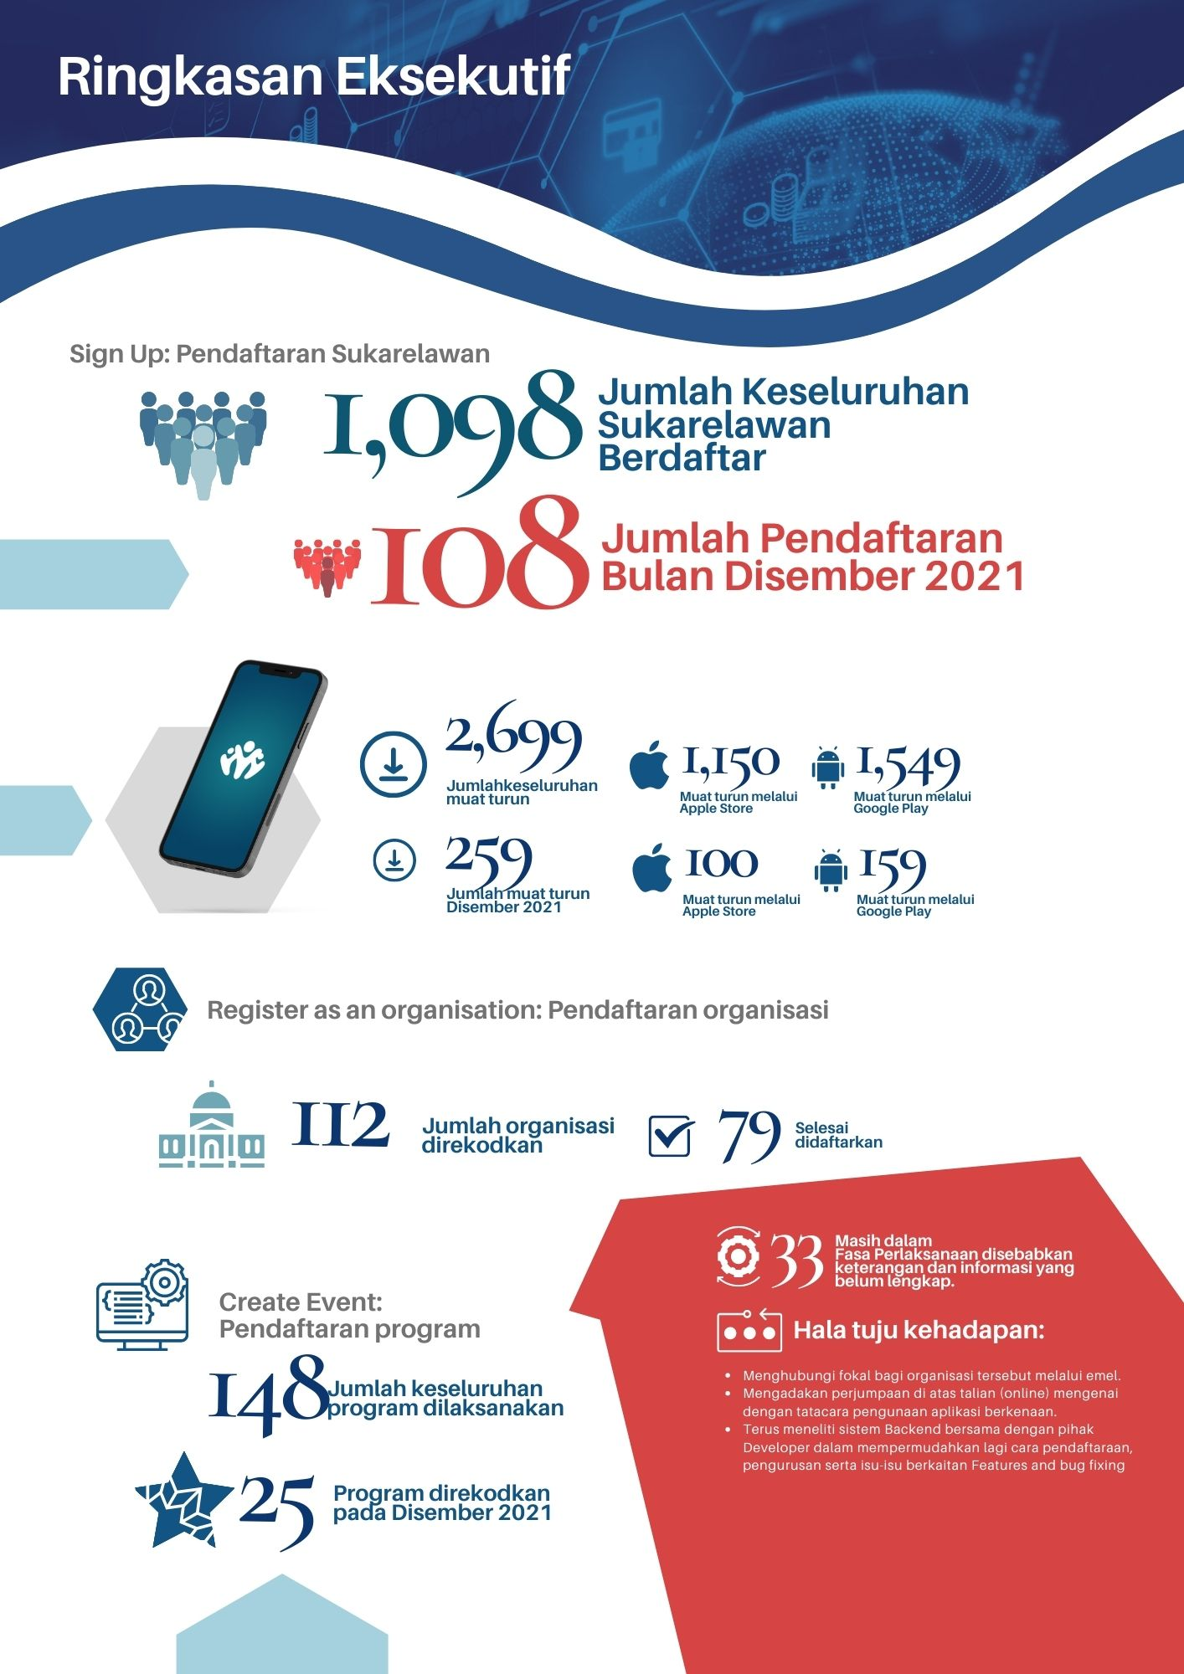

# RINGKASAN EKSEKUTIF

# RINGKASAN STATUS DATA APLIKASI MENGALINGA BAGI OKTOBER 2022

**34 – Oktober 22**

1,715 - Ogos 21- Sept 22

**46 – Oktober 22**

1,510 - Ogos 21-Sept 22

**1 – Oktober 22**

93- Ogos 21- Sept 22

**67 – Oktober 22**

2,143 - Ogos 21- Sept 22

**STATUS SEMASA APLIKASI MENGALINGA BAGI BULAN**

**12 – Oktober 22**

255 - Ogos – Sept 22

**OKTOBER 2022**

# PENDAFTARAN SUKARELAWAN

Keseluruhan Jumlah individu yang telah memuat turun aplikasi ini terus meningkat melalui dua *domain* utama iaitu *\*Apple Store* sebanyak 1,749 bagi telefon pintar *iPhone* yang menggunakan *operating system iOS* dan \**Google Play* 2,210 bagi telefon pintar yang menggunakan *operating system Android* menjadikan jumlah keseluruhan iaitu **3,959 muat turun aplikasi** dengan mencatatkan sebanyak **1,556 pendaftaran individu.**

\*(Maklumat diperolehi daripada *EGNC*)

## DEMOGRAFIK PENDAFTARAN

**2,210**

JUMLAH KESELURUHAN

MUAT TURUN

APLIKASI SEHINGGA OKTOBER 2022



Android

iOS

PECAHAN JUMLAH

SUKARELAWAN MENGIKUT JANTINA

JUMLAH KESELURUHAN PENDAFTARAN

PECAHAN JUMLAH MUAT TURUN APLIKASI SEHINGGA OKTOBER 2022

**1,556**

**3,959**

**1,749**



**45**

**3%**

**1,479**

**95%**



**28**

**2%**



**4**

**0%**

Nota:

Maklumat 4 orang sukarelawan tidak dapat di akses melalui sistem menyebabkan data **Warna Kad Pengenalan Pintar** dan **Daerah** tidak diketahui.  
(1 orang – Okt 21 ; 1 orang – Nov 21, 1 Orang – Dis 22)

Manakala, 1 orang menggunakan No. Passport (Feb 22)

PECAHAN & JUMLAH SUKARELAWAN MENGIKUT BANGSA SEHINGGA OKTOBER 2022

**1,556**

PECAHAN JUMLAH SUKARELAWAN YANG MENDAFTAR MENGIKUT DAERAH SEHINGGA OKTOBER 2022

Brunei Muara 1,157

Tutong

154

Temburong

50

Kuala Belait 192

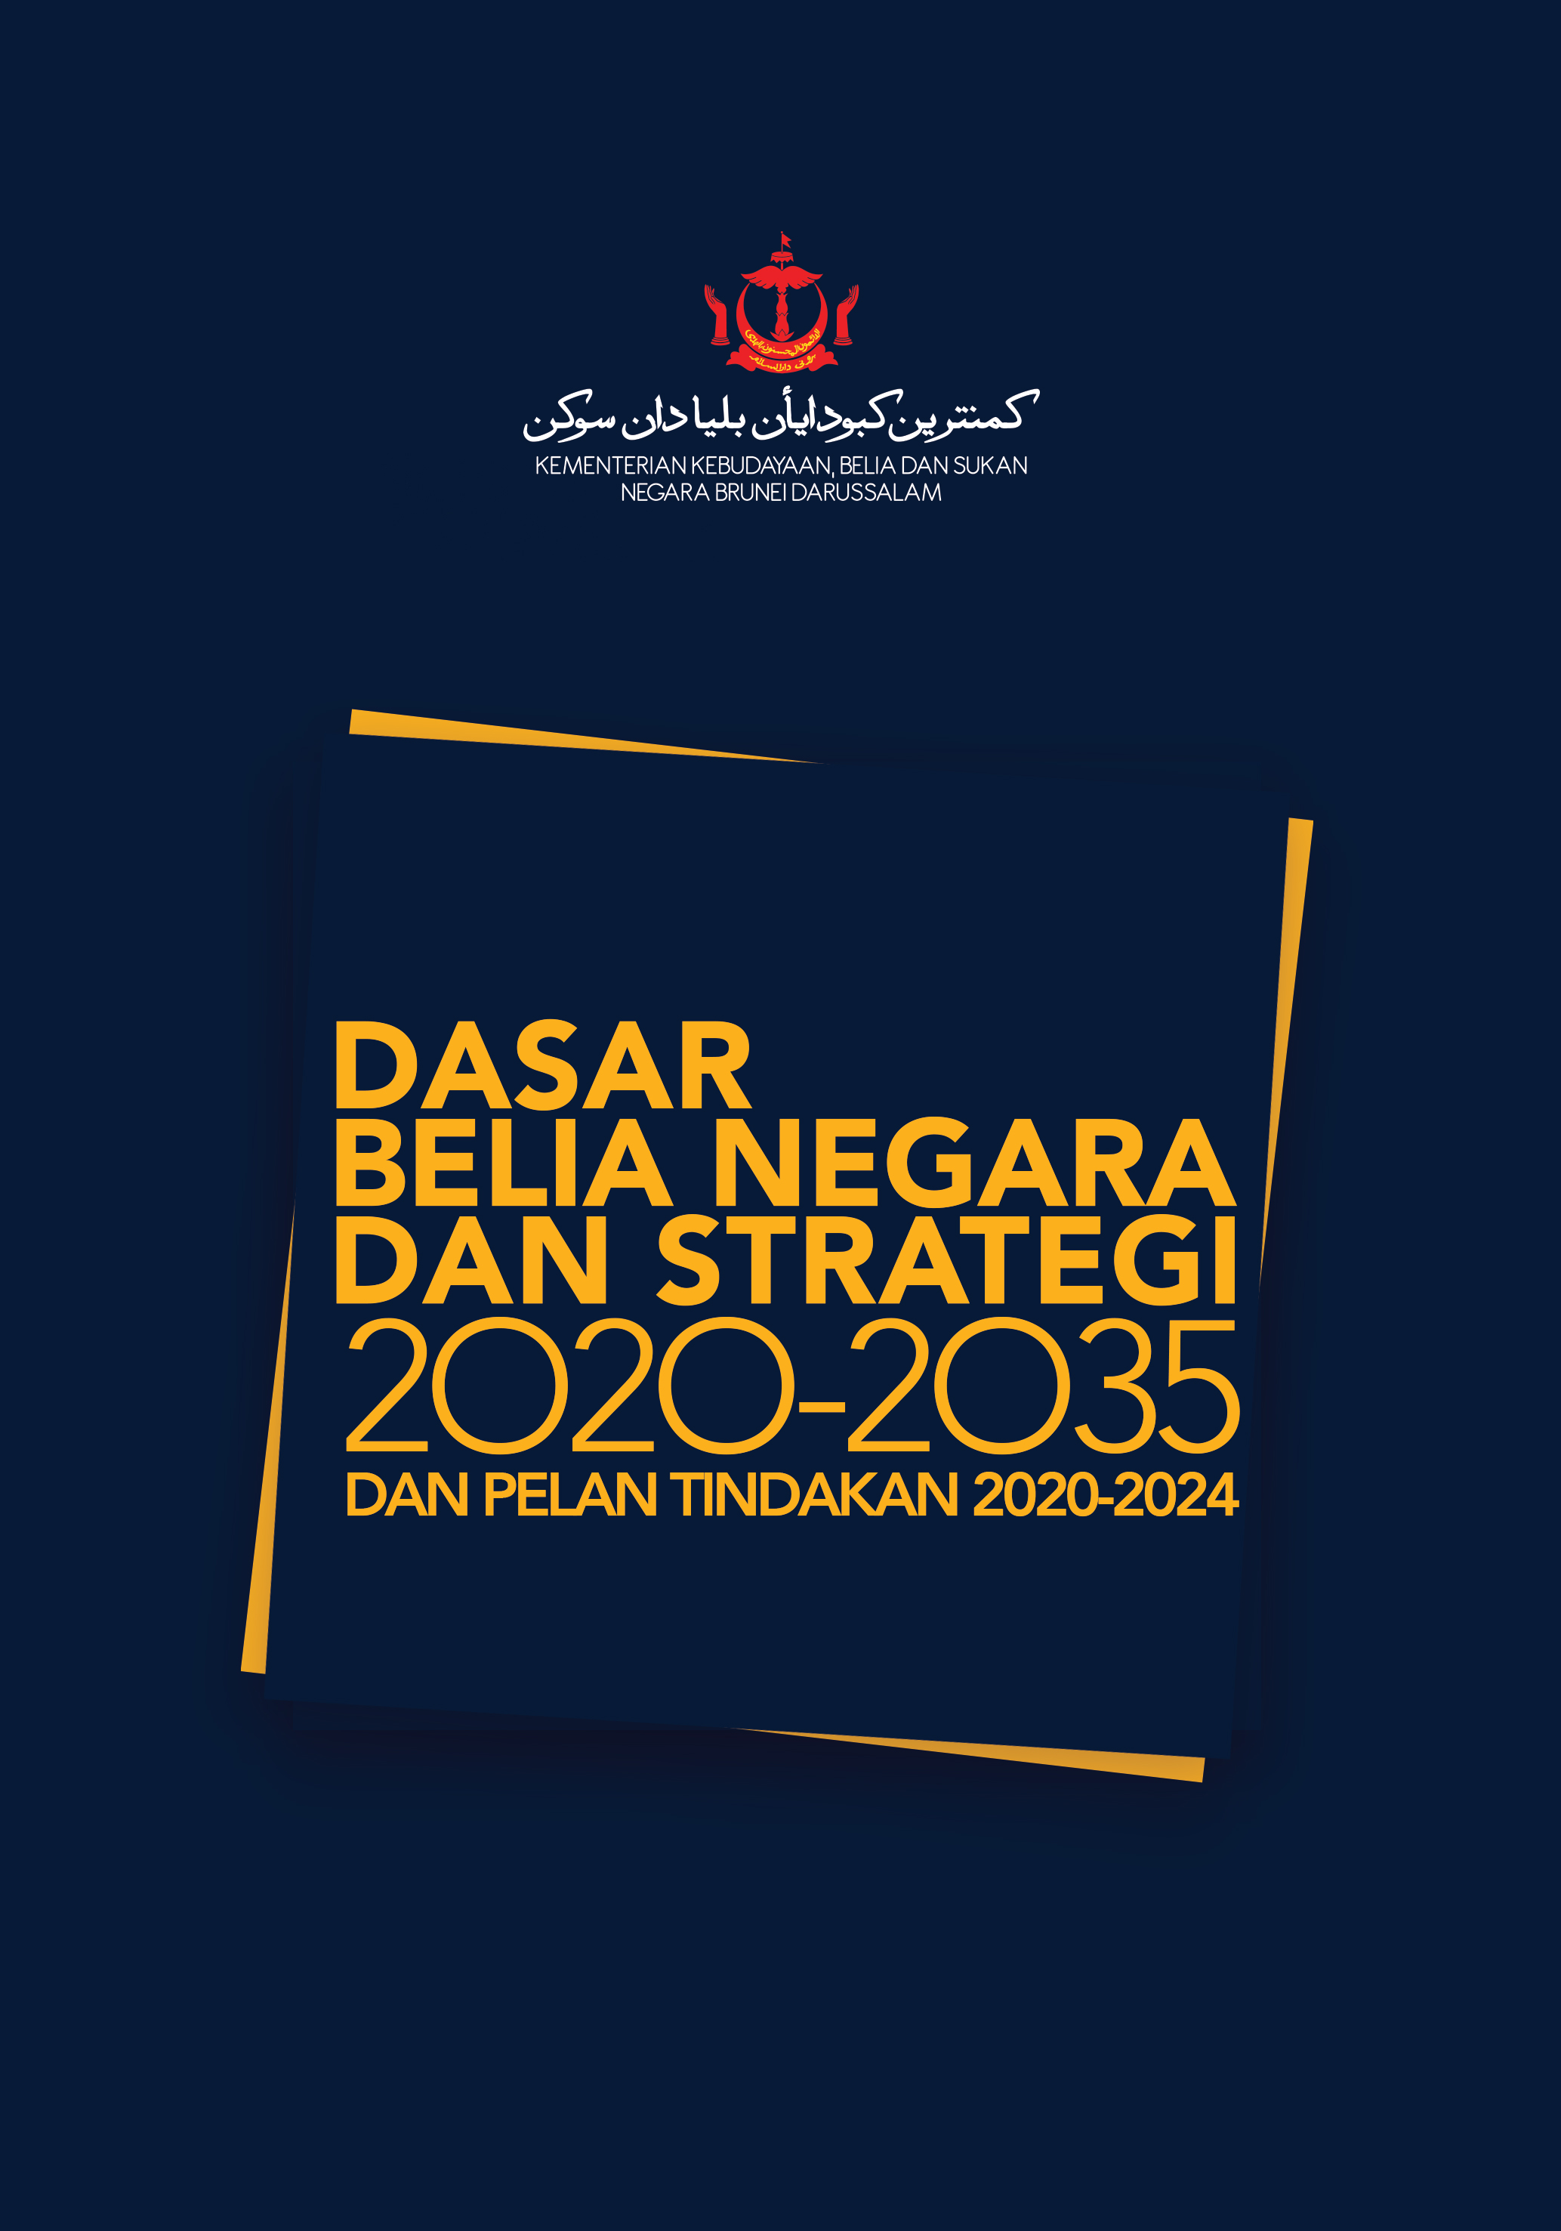

**Peringkat umur mengikut takrif umur belia sepertimana yang dinyatakan di dalam Dasar Belia Negara dan Strategi 2020-2035** menurut pecahan umur seperti berikut:

* 15-35 tahun umur **belia**
* **Pemimpin belia** tidak lebih 45 tahun
* **Mentor Belia** tidak ada batas umur

JUMLAH SUKARELAWAN DENGAN TAKRIF UMUR BELIA MENGIKUT JANTINA SEHINGGA OKTOBER 2022

**Note:**

Terdapat 7 sukarelawan mendaftar yang berumur di bawah 15 tahun seperti berikut:

1 orang dalam bulan Ogos 2021,

1 orang dalam bulan Sept 2021,

3 orang dalam bulan Nov 2021,

1 orang dalam bulan Dis 2021 dan

1 orang dalam bulan Sept 2022

PECAHAN JUMLAH SUKARELAWAN KATEGORI PELAJAR / MAHASISWA MENGIKUT

SEKTOR DAN PERINGKAT PENDIDIKAN SEHINGGA OKTOBER 2022

|  |  |  |  |  |  |  |  |  |  |  |  |  |  |  |  |  |  |  |  |  |  |
| --- | --- | --- | --- | --- | --- | --- | --- | --- | --- | --- | --- | --- | --- | --- | --- | --- | --- | --- | --- | --- | --- |
| Peringkat Pendidikan | | Jan-Mac 2022 | | Apr-Jun 2022 | | Jul-Sept 2022 | | **Oct**  **2022** | | Jumlah Pengajian Kerajaan | | | Jumlah Pengajian Swasta | | | Jumlah Pengajian  Tinggi | | | Jumlah Pengajian Menengah | | |
|
|
|
| L | P | L | P | L | P | **L** | **P** | L | P | J | L | P | J | L | P | J | L | P | J |
|  | Institusi Pengajian Tinggi Kerajaan | 43 | 86 | 7 | 12 | 14 | 29 | **0** | **1** | 64 | 128 | 192 | - | | | 92 | 145 | 237 | - | | |
|  | Institusi Pengajian Tinggi Swasta | 5 | 5 | 2 | 1 | 1 | 2 | **20** | **9** | - | | | 28 | 17 | 45 |
|  | Institusi Pengajian Menengah Kerajaan | 14 | 22 | 1 | 7 | 13 | 5 | **0** | **4** | 28 | 38 | 66 | - | | | - | | | 29 | 41 | 70 |
|  | Institusi Pengajian Menengah Swasta | 0 | 3 | 1 | 0 | 0 | 0 | **0** | **0** | - | | | 1 | 3 | 4 |
| Jumlah Institut Pengajian Kerajaan (Tinggi & Menengah) | |  |  |  |  |  |  |  |  | 92 | 166 | 258 |  | | |  | | | - | | |
|  |  |  |  |  |  |
| Jumlah Institut Pengajian Swasta (Tinggi & Menengah) | |  |  |  |  |  |  |  |  |  | | | 29 | 20 | 49 |
|  |  |  |  |  |  |
| Jumlah Institut Pengajian Tinggi  (Kerajaan & Swasta) | |  |  |  |  |  |  |  |  |  | | | | | | 92 | 145 | 237 | - | | |
|  |  |  |  |  |  |
| Jumlah Institut Pengajian Menengah  (Kerajaan & Swasta) | |  |  |  |  |  |  |  |  |  | | | | | | - | | | 29 | 41 | 70 |
|  |  |  |  |  |  |

## SENARAI TRAILBLAZER BAGI SUKARELAWAN 10 TERTINGGI BAGI BULAN OKTOBER 2022

| MAKLUMAT PERIBADI SUKARELAWAN | MAKLUMAT SUKARELAWAN |
| --- | --- |
| |  |  | | --- | --- | | Nama : | Nurul Izyan Anver | | Tarikh Lahir : | 22 Jul 1990 | | Umur : | 31 | | Jantina : | Perempuan | | Sektor : | Sektor Swasta | | Bangsa : | Melayu | | Daerah : | Brunei Muara | | No. Tel : | 8660185 | | |  |  |  | | --- | --- | --- | | Trailblazer Position : | 1 | | | Points : | 225 | | | RSVP : | 52 | | | Event Completed : | 42 events | | |  |  | | | Top 3 Causes : | Animal Rights | | |  | Community | | |  | Youth Development | | |  |  | | | Badge Collection Progress : | Earth Buddy | 60% | | Compassionate Friend | 100% | | Life Saver | 80% | | Great Helper | 100% | |
| |  |  | | --- | --- | | Nama : | Mohammad Zheimie Harith bin Mohammad Zamri | | Tarikh Lahir : | 15 Apr 1997 | | Umur : | 24 | | Jantina : | Lelaki | | Sektor : | Penuntut Institut Tinggi Kerajaan | | Bangsa : | Melayu | | Daerah : | Brunei Muara | | No. Tel : | 8182543 | |  |  | | |  |  |  | | --- | --- | --- | | Trailblazer Position : | 2 | | | Points : | 200 | | | RSVP : | 55 | | | Event Completed : | 39 events | | |  |  | | | Top 3 Causes : | Education | | |  | Spiritual & Religion | | |  | Youth Development | | |  |  | | | Badge Collection Progress : | Earth Buddy | 40% | | Compassionate Friend | 100% | | Life Saver | 100% | | Great Helper | 100% | |  |  |  | |
| |  |  | | --- | --- | | Nama : | Nur Sabrina Brahim | | Tarikh Lahir : | 04 Jun 1999 | | Umur : | 26 | | Jantina : | Perempuan | | Sektor : | Sektor Swasta | | Bangsa : | Melayu | | Daerah : | Brunei Muara | | No. Tel : | 7101083 | |  |  | | |  |  |  | | --- | --- | --- | | Trailblazer Position : | 3 | | | Points : | 155 | | | RSVP : | 31 | | | Event Completed : | 29 events | | |  |  | | | Top 3 Causes : | Community | | |  | Disaster Relief | | |  | Green Initiative | | |  |  | | | Badge Collection Progress : | Earth Buddy | 60% | | Compassionate Friend | 100% | |  | Life Saver | 60% | |  | Great Helper | 100% | |
| |  |  | | --- | --- | | Nama : | Badri Aiman Khan Bin Badrul Zeman Khan | | Tarikh Lahir : | 29 Oct 2003 | | Umur : | 18 | | Jantina : | Lelaki | | Sektor : | Penuntut Institut Tinggi Kerajaan | | Bangsa : | Melayu | | Daerah : | Brunei Muara | | No. Tel : | 8286924 | |  |  | | |  |  |  | | --- | --- | --- | | Trailblazer Position : | 4 | | | Points : | 145 | | | RSVP : | 45 | | | Event Completed : | 21 events | | |  |  | | | Top 3 Causes : | Animal Rights | | |  | Green Initiative | | |  | Youth Development | | |  |  | | | Badge Collection Progress : | Earth Buddy | 20% | | Compassionate Friend | 100% | |  | Life Saver | 20% | |  | Great Helper | 100% | |
| |  |  | | --- | --- | | Nama : | Syafiqah mumtazah binti Haji Mohd Arriffen | | Tarikh Lahir : | 13 Mar 2005 | | Umur : | 16 | | Jantina : | Perempuan | | Sektor : | Secondary Public Student | | Bangsa : | Melayu | | Daerah : | Brunei muara | | No. Tel : | 8364878 | |  |  | | |  |  |  | | --- | --- | --- | | Trailblazer Position : | 5 | | | Points : | 140 | | | RSVP : | 49 | | | Event Completed : | 27 events | | |  |  | | | Top 3 Causes : | Community | | |  | Education | | |  | Youth Development | | |  |  | | | Badge Collection Progress : | Compassionate Friend | 100% | | Life Saver | 20% | |  | Great Helper | 100% | |  |  |  | |
| |  |  | | --- | --- | | Nama : | Haji Abdul Afiq bin Zainuddin | | Tarikh Lahir : | 22 May 1988 | | Umur : | 33 | | Jantina : | Lelaki | | Sektor : | Kerajaan | | Bangsa : | Chinese | | Daerah : | Belait | | No. Tel : | 8255940 | | |  |  |  | | --- | --- | --- | | Trailblazer Position : | 6 | | | Points : | 140 | | | RSVP : | 38 | | | Event Completed : | 27 events | | |  |  | | | Top 3 Causes : | Disaster Relief | | |  | Social Entrepreneurship | | |  | Youth Development | | |  |  | | | Badge Collection Progress : | Earth Buddy | 20% | | Compassionate Friend | 100% | |  | Life Saver | 20% | |  | Great Helper | 100% | |  |  |  | |
| |  |  | | --- | --- | | Nama : | Khairunnisa Ash’ari | | Tarikh Lahir : | 15 Dec 1987 | | Umur : | 33 | | Jantina : | Perempuan | | Sektor : | Bekerja Sendiri | | Bangsa : | Melayu | | Daerah : | Brunei Muara | | No. Tel : | 8626588 | |  |  | | |  |  |  | | --- | --- | --- | | Trailblazer Position : | 7 | | | Points : | 135 | | | RSVP : | 54 | | | Event Completed : | 26 events | | |  |  | | | Top 3 Causes : | Community | | |  | Green Initiative | | |  | Youth Development | | |  |  | | | Badge Collection Progress : | Earth Buddy | 80% | | Compassionate Friend | 100% | | Life Saver | 40% | |  | Great Helper | 100% | |  |  |  | |
| |  |  | | --- | --- | | Nama : | Nur Fatin Farhanah Binti Abdullah | | Tarikh Lahir : | 04 Jun 1999 | | Umur : | 22 | | Jantina : | Perempuan | | Sektor : | Penuntut Institut Tinggi Kerajaan | | Bangsa : | Chinese | | Daerah : | Brunei Muara | | No. Tel : | 8835561 | |  |  | |  |  | | |  |  |  | | --- | --- | --- | |  |  | | | Trailblazer Position : | 8 | | | Points : | 135 | | | RSVP : | 32 | | | Event Completed : | 26 events | | |  |  | | | Top 3 Causes : | Community | | |  | Social Entrepreneurship | | |  | Youth Development | | |  |  | | | Badge Collection Progress : | Earth Buddy | 20% | | Compassionate Friend | 100% | |  | Life Saver | 20% | |  | Great Helper | 100% | |  |  |  | |
| |  |  | | --- | --- | | Nama : | Auni Fikriah bt Mohammad Azlan | | Tarikh Lahir : | 27 Oct 2001 | | Umur : | 20 | | Jantina : | Perempuan | | Sektor : | Penuntut Institut Tinggi Kerajaan | | Bangsa : | Melayu | | Daerah : | Tutong | | No. Tel : | 8113645 | |  |  | |  |  | | |  |  |  | | --- | --- | --- | | Trailblazer Position : | 9 | | | Points : | 125 | | | RSVP : | 25 | | | Event Completed : | 21 events | | |  |  | | | Top 3 Causes : | Community | | |  | Green Initiative | | |  | Youth Development | | |  |  | | | Badge Collection Progress : | Earth Buddy | 40% | | Compassionate Friend | 100% | |  | Life Saver | 20% | |  | Great Helper | 100% | |
| |  |  | | --- | --- | | Nama : | Muhammad Syafiq bin Haji Alihan | | Tarikh Lahir : | 17 Jul 1997 | | Umur : | 24 | | Jantina : | Lelaki | | Sektor : | Jobseeker | | Bangsa : | Melayu | | Daerah : | Tutong | | No. Tel : | 8890984 | | |  |  |  | | --- | --- | --- | | Trailblazer Position : | 10 | | | Points : | 115 | | | RSVP : | 31 | | | Event Completed : | 21 events | | |  |  | | | Top 3 Causes : | Community | | |  | Spiritual & Religion | | |  | Youth Development | | |  |  | | | Badge Collection Progress: | Earth Buddy | 20% | | Compassionate Friend | 100% | |  | Life Saver | 20% | |  | Great Helper | 100% | |  |  |  | |  |  |  | |

# page13image10840432PENDAFTARAN ORGANISASI

Jumlah keseluruhan organisasi yang berdaftar mulai **7 Ogos 2021 hingga 31 Oktober 2022** ke dalam Aplikasi Mengalinga adalah sebanyak **130 buah organisasi.** Walau bagaimana sistem ini telah mengenal pasti sebanyak **36 buah organisasi masih dalam proses pendaftaran** disebabkan beberapa perkara yang akan dikongsikan dalam bahagian, cabaran dan isu pendaftaraan.

Sebagai panduan, **94 organisasi** yang selesai membuat pendaftaran mengikut 9 klasifikasi masing-masing iaitu:

## CARTA & PECAHAN PENDAFTARAN ORGANISASI SEHINGGA OKTOBER 2022

**130**

PECAHAN PENDAFTARAN ORGANISASI 2022

|  |  |  |
| --- | --- | --- |
| Jumlah Organisasi Yang Mendaftar | | |
| **Ogos 2021 hingga September 2022** | | **OKTOBER 2022** |
| 93 Organisasi | | 1 Organisasi |
| Senarai Agensi/ Organisasi/ Syarikat/ Badan-Badan | | |
| Registrar of Society (ROS) | | |
| Ogos 2021 | 1. Persatuan Alumni Sultan Scholar Persatuan 2. Kemajuan Insan (KESAN) 3. Brunei Darussalam Aids Council (BDCB) 4. Global Awareness and Impact Alliance (GAIA) 5. APPA Management 6. Majlis Belia Brunei 7. Youth Entrepreneurs Association Brunei |  |
| Oktober 2021 | 1. Brunei Darussalam National Judo Federation 2. Persatuan Paintball Kebangsaan Negara Brunei Darussalam 3. Brunei Squash Racket Association 4. We Care 5. Persatuan Pembela 6. Persatuan Pandu Putri 7. Beach Bunch |
| November 2021 | 1. Majlis Kesejahteraan Masyarakat (MKM) 2. Persatuan Melayu Kedayan |
| Disember 2021 | 1. Persatuan Pengakap Daerah Temburong 2. Demensia Brunei |
| Januari 2022 | 1. Persatuan Pengakap Negara Brunei Darussalam 2. BruWILD |
| Mei 2022 | 1. Legasi Generasi |
| Ogos 2022 | 1. Football Association of Brunei Darussalam |
| Agensi Kerajaan | | |
| Ogos 2021 | 1. Sukarelawan JAPEM 2. Persatuan C.A.R.E 3. N3C19-HQI 4. Outward Bound Brunei Darussalam (OBBD) 5. Voice Within |  |
| Oktober 2021 | 1. Pusat Sejarah Brunei 2. Pusat Belia, Temburong 3. Pusat Belia, Tutong |
| November 2021 | 1. Bahagian Belia, Jabatan Belia dan Sukan 2. Syababul Wafa 3. Entrepreneurship Innovation Centre, Kementerian Pendidikan |
| Disember 2021 | 1. Kolej Universiti Perguruan Ugama Seri Begawan 2. IBTE Sultan Bolkiah Campus |
| Januari 2022 | 1. Jabatan Alam Sekitar, Taman dan Rekreasi 2. Kementerian Kewangan dan Ekonomi |
| Mac 2022 | 1. Dewan Bahasa dan Pustaka Brunei 2. Jabatan Pembangunan Masyarakat 3. Heart Heroes ASEAN |
| September 12022 | 1. Jabatan Belia dan Sukan Cawangan Daerah Belait |  |
| Pergerakan Belia dan Komuniti / Persatuan-Persatuan di Institusi Pengajian Tinggi | | |
| Ogos 2021 | 1. My Action for SDGs 2. Kumpulan Impak (Pusat Belia Tutong) 3. ASEAN Youth Advocate Network (AYAN) 4. Alumni Program Belia Cinta Tanah Air 5. Youth Southeast Asian Leadership Initiatives (YSEALI) 6. Just Bruneian 7. Glow Up With in (IPA Program YEP) 8. Sealnet Project Brunei Youth RISE 9. Malam Minggu Pusat Belia 10. Projek Assalamualaikum |  |
| September 2021 | 1. Kumpulan Putra 2. Seni Sukarelawan Belia C-19 |
| Oktober 2021 | 1. Kelab Belia Permata Hijau Temburong 2. Global Shapers Community Bandar Seri Begawan 3. Kelab Komuniti Belia Transformasi |
| November 2021 | 1. Syababul Iman 2. YSEALI Women Leadership Academy (WLA) Alumni Network |
| Disember 2021 | 1. Environmental IBTE 2. Persatuan Mahasiswa/wi Universiti Brunei 3. Majlis Perwakilan Pelajar Universiti Teknologi Brunei 4. IBTE Kampus Agro-Teknologi 5. MPK RPN Kg Panchor |
| Mac 2022 | 1. Al-Jiilul Faatih |
| April 2022 | 1. Masjid Rashidah Sa’adatul Bolkiah Kg Sg Akar |
| Syarikat Swasta (ROCBN) | | |
| Ogos 2021 | 1. Suara Kitani 2. Projek FEED Management Services Projek 3. Bina Ukhwah 4. Medley House Production 5. Kilang ReRoot 6. Green Brunei 7. AL-Huffaz Management 8. Al-Huffaz Leader 9. Mc Donald, Brunei 10. Tambang.BN 11. Big BWN Project 12. Matters of Choice 13. Perspective Insan 14. Young Professional Network | 1. Google Developer Group Brunei |
| Oktober 2021 | 1. MakLong BN 2. Minda Youth Movement |
| November 2021 | 1. Sukarelawan Daerah Tutong (SUKA) 2. EICO Enterprise |
| Disember 2021 | 1. Shell LiveWIRE (B) |
| Januari 2022 | 1. Badan Sukarelawan Belia Da’ie 2. Royal Brunei Catering Sdn Bhd 3. Progresif Sdn Bhd 4. Pawsup |
| Februari 2022 | 1. Al-Amin Recovery Management 2. Tele Directories (B) Sdn Bhd |
| Mac 2022 | 1. Women Techmakers Brunei |
| Mei 2022 | 1. InfoCom Federation Brunei (IFB) |
| Jun 2022 | 1. Baiduri Bank |

## DAPATAN DARI HASIL PENGUMPULAN DATA

Secara keseluruhan 94 organisasi telah berjaya mendaftarkan diri sehingga 31 Oktober 2022. Daripada jumlah tersebut majoriti organisasi yang berdaftar yang tertinggi adalah dari sektor Pergerakan Belia (24 organisasi) dan Syarikat Swasta (29 organisasi). Manakala sektor yang terendah adalah dari sektor sukan (4 organisasi) yang merangkumi persatuan-persatuan sukan.

Beberapa pendekatan telah pun dilaksanakan untuk meningkatkan lagi pendaftaraan organisasi pada bulan berkenaan. Ini telah dijalankan melalui:

* Perjumpaan dengan stakeholders dan agensi-agensi kerajaan dan swasta.
* Menulis surat-surat ke kementerian-kementerian dan juga *Government Link Companies* mengenai dengan Mengalinga.
* Menggalakkan organisasi yang berdaftar untuk sentiasa menyiarkan video promosi aplikasi dalam mana-mana aktiviti yang bersesuaian.
* Sentiasa berhubung terus dengan pihak Pasukan Petindak.

## SENARAI HIGHFLYERS BAGI ORGANISASI 10 TERATAS BAGI BULAN OKTOBER 2022

| MAKLUMAT ORGANISASI | |
| --- | --- |
| |  |  | | --- | --- | | Nama Organisasi : | Green Brunei | | Tahun Penubuhan : | 15 Ogos 2012 | | No. Organisasi : | ROCBN P/92573/2012 | | Pengasas : | YB Dayang Khairunnisa binti Awang Haji Ash’ari | | Alamat : | No 14 Spg 853 Kg Tasek Meradun, Jln Tutong BF1520 | | E-Mel : | info@green-brunei.com | | No. Tel : | 8250995 | |  |  | | |  |  |  | | --- | --- | --- | | Highflyers Position : | 1 | | | Klasifikasi : | Animal Rights  Community  Education  Green Initiative  Social Entrepreneurship  Youth Development | | | Keahlian : | 7 Orang | | | Program Dilaksanakan : | 54 | | |  |  | | | Badge : | Mobiliser | 7% | |  | M Bronze Proud Medal | 100% | |  | M Silver Proud Medal | 100% | |  | M Gold Proud Medal | 100% | |  | Earth Buddy | 100% | |  |  | |   Youth-led platform to promote environmental sustainability through education, conservation and advocacy. Green Brunei has organized numerous workshops, recycling programmes, cleanups and tree plantings, reaching out to thousands of youth from all four districts. |
| 1   |  |  | | --- | --- | | Nama Organisasi : | Beach Bunch Association | | Tahun Penubuhan : | 16 Jun 2010 | | No. Organisasi : | - | | Presiden : | Rizan Latif | | Alamat : | 16 Spg 535 Jalan Jerudong, Jerudong | | E-Mel : | thebeachbunch@gmail.com | | No. Tel : | 8732271 | | |  |  | | --- | --- | | Highflyers Position : | 2 | | Klasifikasi : | Community  Green Initiative | | Keahlian : | 20 Orang | | Program Dilaksanakan : | 17 |   Lifesaving and Cleanup organisation at the Kingdom of Unexpected Treasures |
| |  |  | | --- | --- | | Nama Organisasi: | Majlis Belia Brunei (MBB) | | Tahun Penubuhan : | 20 April 1965 | | No. Organisasi: | ROCBN P/92573/2012 | | Timbalan Yang Di-Pertua : | Nurul Izyan Anver | | Alamat : | Bilik Operasi Majlis Belia Brunei, Pusat Belia, Bandar Seri Begawan, Jalan Kampong Berangan, Bandar Seri Begawan BS8211 | | E-Mel : | info.bruneiyouthcouncil@gmail.com | | No. Tel : | 8660185 | |  |  | | |  |  |  | | --- | --- | --- | | Highflyers Position : | 3 | | | Klasifikasi : | Youth Development  Education  Community | | | Keahlian : | 32 Orang | | | Program Dilaksanakan : | 12 | | |  |  | | | Badge : | Mobiliser | 4% | |  | M Bronze Proud Medal | 80% | |  | M Silver Proud Medal | 40% | |  | M Gold Proud Medal | 27% |   Majlis Belia Brunei (MBB) merupakan badan induk bagi gabungan  persatuan dan pergerakan belia yang berdaftar di seluruh Negara Brunei Darussalam. MBB adalah sebuah Persatuan NGO (Non-Governmental Volunteer Organisation). Salah satu Objektif MBB adalah untuk menyatukan belia- belia dan badan- badan Persatuan & Pergerakan di Negara Brunei Darussalam untuk membantu membangunkan negara Brunei Darusaalam dari segala aspek kehidupan, ekonomi, Sosial dan alam sekitar dengan selaras dengan falsafah Melayu Islam Beraja, Wawasan 2035 dan Dasar Belia Negara Brunei Darussalam. |
| |  |  | | --- | --- | | Nama Organisasi: | Young Professionals Network Brunei (YPN) | | Tahun Penubuhan : | 1 Februari 2019 | | Pegawai Fokal : | Siti Noraspadiyah Hj Mohd Sah | | Alamat : | Jalan Tungku Link, Mukim Gadong BE1410 | | E-Mel : | youngprofessionals.bn@gmail.com | | No. Tel : | 8890020 | |  |  | | |  |  |  | | --- | --- | --- | | Highflyers Position : | 4 | | | Klasifikasi : | Youth Development | | | Keahlian : | 12 Orang | | | Program Dilaksanakan : | 18 | | |  |  | | | Badge : | Mobiliser | 3% | |  | M Bronze Proud Medal | 100% | |  | M Silver Proud Medal | 60% | |  | M Gold Proud Medal | 40% |   The Young Professionals Network Brunei (YPNBrunei) is a network setup as a platform to nurture personal and professional growth of young professionals in Brunei Darussalam through key initiatives such as networking, dialogue, mentorship and advocacy. Founded and led by a group of passionate young professionals From diverse backgrounds, they aspire to keep this network inclusive, engaging, meaningful and impactful and aim to promote and empower employability and champion young professionals’ capacity for leadership at various levels. |
| 1   |  |  | | --- | --- | | Nama Organisasi : | Google Developer Group Brunei | | Tahun Penubuhan : | 03 April 2010 | | No. Organisasi : | GDG Brunei | | Ketua : | Ho Ying Ying | | Alamat : | Bilik Operasi Majlis Belia Brunei, Pusat Belia BSB, Jabatan Belia dan Sukan, Kementerian Kebudayaan Belia dan Sukan, Kpg. Berangan, Jalan Kianggeh | | E-Mel : | gdgbrunei@gmail.com | | No. Tel : | 8140664 | |  |  | | |  |  | | --- | --- | | Highflyers Position : | 5 | | Klasifikasi : | Community  Youth Development  Education | | Keahlian : | 6 Orang | | Program Dilaksanakan : | 4 |   Majlis Belia Brunei Affiliates and Tech Community Chapter of InfoCom Federation Brunei. This is a group for anyone interested in exploring Google technologies. Let's get together to learn together. All are welcome to share your skills and knowledge. This is the platform where we can share, learn, develop and grow together. Disclaimer: GDG Brunei Darussalam is an independent group; our activities and the opinions expressed here should in no way be linked to Google, the corporation. To learn more about the GDG program, visit https://developers.google.com/community/gdg/ |
| |  |  | | --- | --- | | Nama Organisasi: | Persatuan Mahasiswa/wi Universiti Brunei Darussalam | | Tahun Penubuhan : | 28 Okt 1986 | | No. Organisasi: | PMUBD | | Pegawai Fokal : | Mohammad Hafeezul Waezz bin Rabu | | Alamat : | Bilik 1.31, PMUBD Office, Bangunan Hal Ehwal Pelajar, Universiti Brunei Darussalam | | E-Mel : | pmubd.hep@ubd.edu.bn | | No. Tel : | - | |  |  | | |  |  |  | | --- | --- | --- | | Highflyers Position : | 6 | | | Klasifikasi : | Youth Development  Education  Animal Rights  Arts & Creative  Community  Disaster Relief  Spiritual & Religion  Social Entrepreneurship | | | Keahlian : | 2000 Orang | | | Program Dilaksanakan : | 7 | | |  |  | | | Badge : | Mobiliser | 1% | |  | M Bronze Proud Medal | 20% | |  | M Silver Proud Medal | 10% | |  | M Gold Proud Medal | 7% | |  |  | |   Persatuan Mahasiswa/i Universiti Brunei Darussalam (PMUBD) is an official students’ association in Universiti Brunei Darussalam (UBD) that was established since 1986. The administration of the association is run by the members of the Student Representative Council with the support, guidance, and cooperation from the Student Affairs Section of UBD especially to hold activities and initiatives throughout the university. PMUBD's vision is for students to reach human excellence and mission is to lead towards human excellence. |
| |  |  | | --- | --- | | Nama Organisasi : | Dewan Bahasa dan Pustaka Brunei | | Tahun Penubuhan : | 1 Januari 1965 | | No. Organisasi : | - | | Pegawai Fokal : | Nor Rafidah binti Haji Mokhtar | | Alamat : | Dewan Bahasa dan Pustaka, Jalan Pembangunan, Lapangan Terbang Lama Berakas, BB3510, Negara Brunei Darussalam | | E-Mel : | info@dbp.gov.bn | | No. Tel : | 2382511 | |  |  | | |  |  | | --- | --- | | Highflyers Position : | 7 | | Klasifikasi : | Arts & Creative  Education  Youth Development | | Keahlian : | 329 Orang | | Program Dilaksanakan : | 25 | |  |  |   Jabatan Kerajaan di bawah Kementerian Kebudayaan, Belia dan Sukan, Negara Brunei Darussalam. Jabatan ini bertanggungjawab sebagai badan Pembinaan dan Pengembangaan Bahasa dan Sastera, Penyelidikan dan Dokumentasi Kebudayaan dan Penerbitan Buku yang terbesar di negara ini, di samping berperanan menyediakan perkhidmatan perpustakaan di seluruh negara. |
| 1   |  |  | | --- | --- | | Nama Organisasi : | Football Association of Brunei Darussalam | | Tahun Penubuhan : | 23 Mei 2011 | | No. Organisasi : | BPD25/1401(S) | | Head of Grassroots Development : | Haji Rozaimienizam bin Haji Jainal | | Alamat : | FABD House, Jalan Pusat Persidangan BB4313 | | E-Mel : | grassroots.fabd@gmail.com | | No. Tel : | 8353247 | |  |  | | |  |  | | --- | --- | | Highflyers Position : | 8 | | Klasifikasi : | Community  Education  Youth Development | | Keahlian : | 20 Orang | | Program Dilaksanakan : | 23 |   FABD vision statement: An efficient and effective organization for the dissemination of resources, planning and implementation of all football activities in Brunei Darussalam at national, regional and international levels. FABD mission statement: Promoting and regulating the activity of the game of football and all aspects connected with it, reconciling the amateur and professional dimension through organization structure. |
| |  |  | | --- | --- | | Nama Organisasi : | Global Shapers Community Bandar Seri Begawan Hub | | Tahun Penubuhan : | 1 Julai 2015 | | No. Organisasi : | - | | Pegawai Fokal : | Syahmi Zulfadhli bin Abdullah @ Mims Sidi | | Alamat : | Bilik Operasi Majlis Belia Brunei, Pusat Belia, Bandar Seri Begawan, Jalan Kampong Berangan, Bandar Seri Begawan BS8211 | | E-Mel : | globalshapers.bsb@gmail.com | | No. Tel : | 8352895 | |  |  | | |  |  | | --- | --- | | Highflyers Position : | 9 | | Klasifikasi : | Youth Development  Community | | Keahlian : | 30 Orang | | Program Dilaksanakan : | 19 | |  |  |   The Global Shapers Community was born out of the World Economic Forum, which aims to create a network of inspiring young people under the age of 30 working together to address local, regional and global challenges. With more than 14,000 members, the Global Shapers Community spans 420 city-based hubs in 171 countries. The Bandar Seri Begawan Hub is a community of passionate individuals committed to shaping a better future for Brunei Darussalam's youth. Responding to employment issues that has been a concern to Brunei Darussalam in recent years, the mission of GSBSB Hub includes:   * To champion youth unemployment issues through capacity building and inclusivity. * To empower young people in Brunei Darussalam to shape a brighter future for themselves. * To deliver the hub objectives through education, engagement, exposure and capacity building. |
| |  |  | | --- | --- | | Nama Organisasi: | KUMPULAN BELIA IMPAK  (IMPAK YOUTH MOVEMENT) | | Tahun Penubuhan : | 1 Februari 2020 | | No. Organisasi: | - | | Chairperson : | Abdul Aziz Bin Hj Hamdan | | Alamat : | Pusat Belia Tutong, Jabatan Belia dan Sukan, Daerah Tutong, Negara Brunei Darussalam | | E-Mel : | beliaimpaktutong@gmail.com | | No. Tel : | 8654208 | |  |  | |  |  | | |  |  | | --- | --- | | Highflyers Position : | 10 | | Klasifikasi : | Youth Development  Education  Community  Social Entrepreneurship  Spiritual & Religion | | Keahlian : | 50 Orang | | Program Dilaksanakan : | 13 | |

# 3. PROGRAM YANG DILAKSANAKAN HINGGA 31 OKTOBER 2022

## DAPATAN DARI HASIL PENGUMPULAN DATA

Secara keseluruhan, perlaksanaan program dan aktiviti yang menggunakan aplikasi ini adalah menggalakan. Sebanyak 12 program telah berjaya dilaksanakan pada bulan Oktober 2022.

# KAJIAN PERBANDINGAN